SNMP Configuration for TIP OLTs
- Vendor: Netlink and Syrotech

Device Information
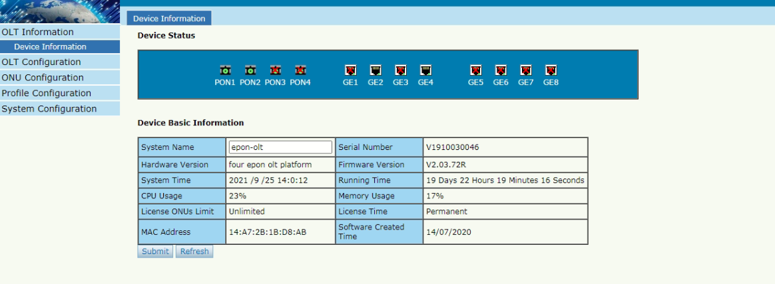
Before Configuration: For SNMP Disabled cases, the IPv4 SNMP will be in DENY state.
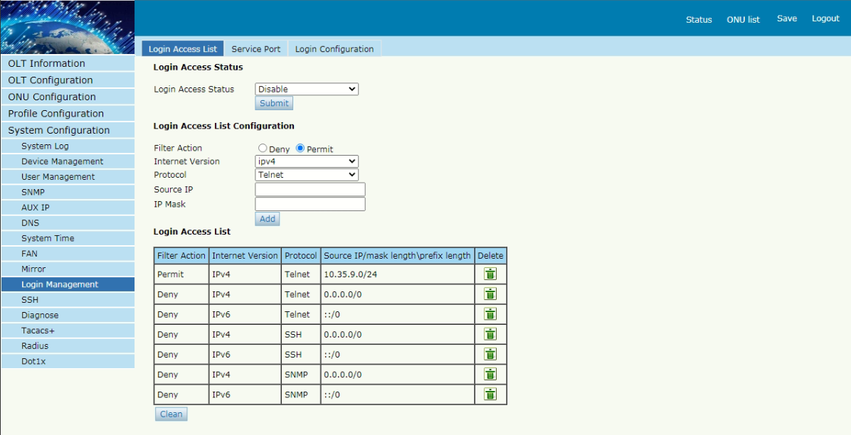
For Configuration: Select following details and then ADD
Filter Action - Permit
Internet Version – IPv4
Protocol – SNMP
Source IP – 172.30.6.0
IP Mask – 255.255.255.0

Similarly, ADD for Source IP – 172.30.22.0 and IP Mask – 255.255.255.128

After Configuration: For the SNMP Enabled cases, the SNMP will be in Permit state for the BBNMS IP Pools.
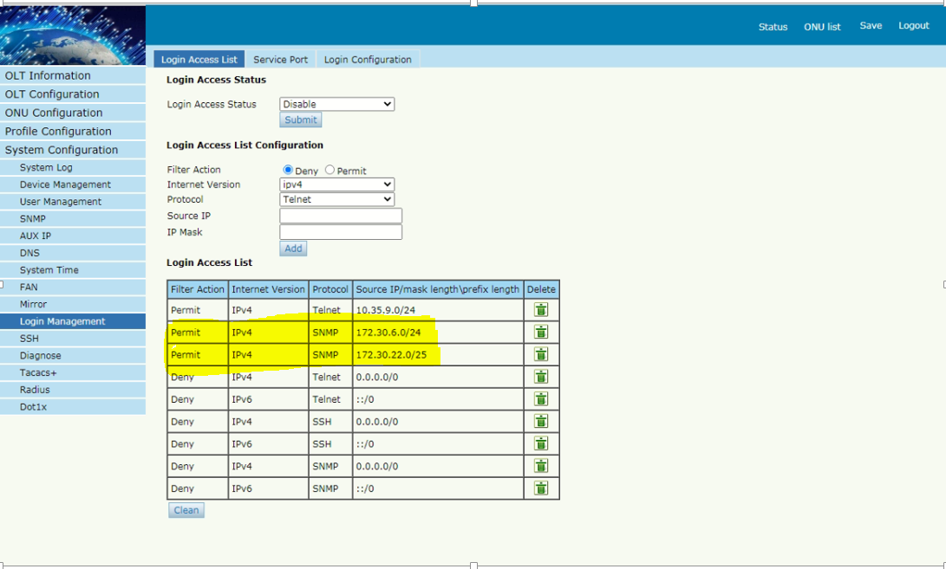

- Vendor: Electroline and Richerlink
Device Information

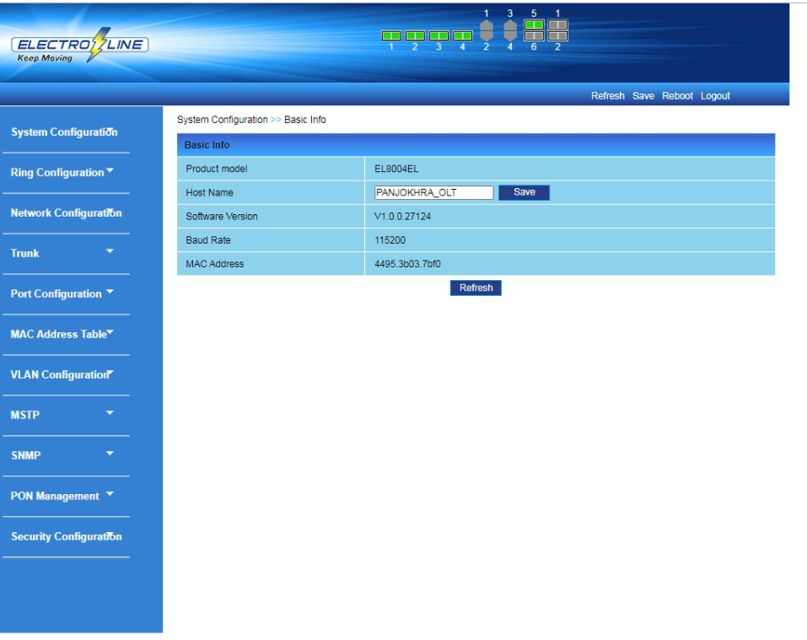
Before Configuration: For SNMP Disabled cases, SNMP Group Management GROUP PROFILE will be having no details regarding GROUP NAME

For Configuration:
SNMP Group Management GROUP NAME = public Access = ro ADD

After Configuration:
For SNMP Enabled cases, SNMP Group Management GROUP PROFILE will be having details regarding GROUP NAME as public with access as ro (read only)
